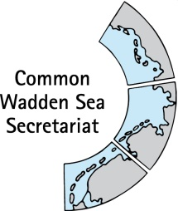
MEETING DOCUMENT
Expert group Climate Change Adaptation (EG-C 13)
9 February 2022
Online meeting

Agenda Item: 2. Summary record
Subject: Draft summary record
Document No.: EG-C 13/2
Date: 22 April 2022
Submitted by: CWSS

This document contains the draft summary record of the EG-C 12 meeting, held 9 February 2022.

Proposal: The group is invited to adopt the draft summary record

Version Log (will be deleted, this is for my personal overview)
Issue Date | Version | Author | Change
2022-02-09 | v0.1 | CWSS | First draft of the document, ,5

DRAFT SUMMARY RECORD v0.1
Meeting of the
Expert Group Climate Change Adaptation (EG-C 12)
9 February 2022
Online meeting

- Opening of the Meeting and adoption of the Agenda
The meeting was opened by the chairperson Robert Zijlstra 09:00 on 09:30 on 9 February 2022. by MS Teams. He passed apologies of Frank Ahlhorn and Saa Kabuta and Andreas Wurpts.
A list of participants is at Annex 1.
The EG-C adopted the draft agenda of the meeting (Annex 2).

- Adoption of the draft summary record
EG-C12-2-Draft-SR-EG-C11v0.3.docx
The chair reviewed the list of action items, of which a side event suggestion is on today´s agenda. , except for 3 (circulate TMAP list). In addi1 done, 2 leave on list Claus and Ester had sent workshop participants for TMAP. Call for Danish contribution. 3 leave on list
The EG-C noted the information and adopted the draft summary record of EG-C11. Re action item 2, Denmark will provide suggestions for Danish participation to a TMAP workshop. Re action item 3: the chair will share a list of TMAP parameters.

- Announcements

Denmark
- Process plan of the coastal defense protection plan, might contain relevant info on more smooth process for licensing for coastal protection.
- Starting with the Danish presidency, Ms Anne Marie Rasmussen will become chair of the Trialteral Wadden Sea Cooperation.

Schleswig-Holstein,
February 1st, SH State Government adopted the 2022 update of the Schleswig-Holstein State Master Plan for Coastal Flood Defense and Coastal Protection. It has a strong focus on climate change adaptation with three components: technical measures, regional planning and the use of ecosystem services. In order to consider future sea level rise, the dimensioning of all technical flood defense measures includes a safety allowance of 0.5 m. The strengthening of state dikes, being the cornerstones of coastal flood defense in Schleswig-Holstein, further includes a flattening of the outer dike slope in order to reduce storm wave run up and to create building reserves for further adaptation as necessary. Safety allowance, flat outer dike slopes and building reserves can together compensate for a sea level rise of up to two meters. In regional plans, priority areas for coastal flood defense, coastal protection and climate change adaptation secure the availability of space needed for technical reinforcements as well as utility-free buffer zones landward of cliffs, dunes and beach ridges to allow for coastal retreat. Finally, the application of ecosystem-based measures, for example salt marsh enhancement techniques, acknowledges and uses the high natural resilience or adaptability of coastal ecosystems to sea level rise. An English paper about the plan and its main contents is prepared for “Die Küste” and will be distributed after publication.
Rangers found small loggerhead turtle after storms – that cannot be acquantied to cc, just drifting around irish sea- tropical species, when water too cold dye b temperature loss..
Lower Saxony
- No announcements sent before the meeting.

Netherlands
- Agenda for Waddengebiet – executing programme planned/drafted. One of the interesting things is that there will be a new knowledge program. Waddenacademie (they were financed by the waddenfonds money, ending in 2028). One ide to give waddneacademie role in knowledge programme in wadden sea.
- One and half years ago LNV has prepared a call for research programme on impacts of climate change – last month, heard that it has been accepted. Now talking to also German and Danish people to see how this can bee corradiated as trilateral research programme.

WWF
- The next webinar planned by Programma Rijke Waddnzee for the Community of Understanding Sediment solutions (11 March 2022), may include a presentation about the sandy coast Sankt Peter Ording project.
WSF
No announcements beforehand

Waddenvereniging
the Dutch government has answered the UNESCO letter mentioned in the previous meeting (https://www.rijksoverheid.nl/binaries/rijksoverheid/documenten/kamerstukken/2022/01/21/bijlage-response-to-concerns-regarding-world-heritage-property-wadden-sea/bijlage-response-to-concerns-regarding-world-heritage-property-wadden-sea.pdf).

CWSS
- In September 2023, a World Heritage conference is planned in the Wadden Sea, climate change will be (main) topic;
- CWSS Annual report 2021 published https://waddensea-worldheritage.org/node/1547
- CWSS announced interest for Wadden Sea World Heritage to be pilot site for a citizen science project focusing on detecting marine fish and red list species through metabarcoding: World Heritage Marine Programme launched citizen science project eDNA Expeditions in marine World Heritage sites - Engaging citizen-scientists in revealing the richness and vulnerability of biodiversity for the conservation of UNESCO sites in a changing climate, in collaboration with the Ocean Biodiversity Information System (OBIS) https://ednaexpeditions.org/
The group noted the information x

- Work plan 2022 - 2026
The group collected activities by means of a whiteboard (see Annex 4 for results).
The group noted the information and agreed that chair and CWSS will come forward with a work plan resulting form the whiteboard session, for continued discussion at EG-C 13. These should include
- Taking up the WSB discussion for development of a SMART work plan for the upcoming presidency, including a discussion on the dilemma depicted in the CWSS annual report 2020 by Philippart et al (previous agenda item 10/1)
- Prepare a trilateral documentation on what kind climate related monitoring is being performed on regional level. (previous agenda item 9/1)
- Discuss implications on EG-C work upon availability of the second workshop CVI report (previous 9/3).

- Trilateral Governmental Conference (TGC)
Document: EG-C12-5-TGC-side event EG-C12-5-2-storybook
Julia Busch informed that Frank Ahlhorn withdrew his side event suggestion on ArtPort (art-science-schools).
Claus von Hoerschelmann introduced the storybook for a short animation on climate change effects on the Wadden Sea, as side event for the Trilateral Governmental Conference (TGC).
Julia Busch reminded to avoid similar animations as those already existing, e.g., https://www.waddensea-worldheritage.org/resources/video-east-atlantic-flyway-explained

Ideas mentioned included
- Broaden up – not only focus on birds
- Show also changes in bird composition
- Start with the Wadden Sea as it is (OUV) and then show changes (loss of OUV)
- Be clear on final message:– to end with a solution. Robert Zijlstra suggested to display the system change and as message to give the Wadden Sea as little stress as possible. Jacobus Hofstede added that for a longer film the message may be how we can adapt and maintain resilience of the Wadden Sea.
The group thanked Claus von Hoerschelmann and agreed on the general concept (ecosystem changes) and “humoristic” style. It should be a short movie (3-max 5 minutes) which should be further elaborated by a “task force” consisting of Claus and Ester with support from CWSS. The group further agreed to seek for external support, e.g., link to QSR authors such as Katja Philippart (for fact suggestions and check) and WWF & CWSS colleagues (bird perspective).
Robert Zijlstra will explore on the possibility to cover costs for the animation with RWS budget.

- Climate Vulnerability Index (CVI)
Document: EG-C 12-6 CVI 2 report
The chair and CWSS informed that the CVI 2 workshop report has been finalised by the CVI developers Scott Heron and Jon Day. The chairs of the Task Group World Heritage (TG-WH) and EG-C and the respective secretaries are preparing a reflection/cover note, which will be shared with TG-WH and EG-C.
The group noted the information and agreed to discuss the (future) reflections in an email consultation and, if necessary arrange for an ad hoc meeting. Aim is to inform the Wadden Sea Board (WSB) at their WSB 36 meeting on 28 April 2022.

- Any Other Business and next meeting
There was no other business.
EG-C 13 Tuesday 26 April, 2022 (online) Frank will report on Trilawatt, Saa on Presentation of list of new Alien Species by Saa Kabuta
EG-C 14 summer, in person with excursion 27 – 29 June 2022 (exact times to be determined). Excursion to Ameland, to be organized by Robert.
The group noted the information.

- Closing
The Chairperson closed the meeting than 12:00 on 9 February 2022.and thanked participants for a fruitful discussion.

ANNEX 1: List of participants
LIST OF PARTICIPANTS
Expert group Climate Change Adaptation
(EG-C 12)
09 February 2022
Online meeting

Chair
Mr Robert Zijlstra
Ministry of Infrastructure and Water Management
Noord Nederland
Leeuwarden
phone: +31 (0) 6 224 818 36
EMail: robert.zijlstra@rws.nl
Denmark
Mr Thomas Larsen  Ministry of Environment  Danish Coastal Authority  Højbovej 1, DK - 7620 Lemvig  phone: +45 99 63 63 63  EMail: tla@kyst.dk |  | Mr Klaus Bertram Fries  Varde Municipality  Bytoften 2 , DK - 6800 Varde  phone: +45 (0) 79 94 71 10  EMail: klbf@varde.dk
Germany (Hamburg, Lower Saxony, Schleswig-Holstein)
Mr Claus von Hoerschelmann  Schleswig-Holstein Agency for Coastal Defense, National Park and Marine Conservation  National Park Authority Schleswig-Holstein Nationalpark-Zentrum Multimar Wattforum Dithmarscher Straße 6a 25832 Tönning  Phone +49 (0)4861 9620-15  EMail: Claus.vonHoerschelmann@lkn.landsh.de |  | Mr Jacobus Hofstede  Ministry of Energy, Agriculture, the Environment, Nature and Digitalization Schleswig Holstein,  Mercatorstraße 3, D-24106 Kiel  Postfach 71 51, D-24171 Kiel  Phone: +49(0) 431 988 4984  Mobile: +49 1520 6537300  E-Mail: jacobus.hofstede@mlur.landsh.de
Netherlands
See chair
Participants from advisors to WSB and external experts
Mr Jannes Fröhlich  WWF, Wadden Sea Office  Hafenstraße 3  D - 25813 Husum  phone: +49 (0)4841 66 85 58  mobile: +49 (0)151 18854818  jannes.froehlich@wwf.de |  | Ms Ester Kuppen  Waddenvereniging  Postbus 90  NL-8860 AB Harlingen  phone:+31 (0)6-10883266 kuppen@waddenvereniging.nl
Secretary
Ms Julia A Busch
Common Wadden Sea Secretariat

ANNEX 2: Final agenda
FINAL AGENDA v0.2
Expert group Climate Change Adaptation
(EG-C 12)
9 February 2022
Online meeting

- Opening of the Meeting and adoption of the Agenda
The meeting will be opened by the Chairperson at 09:30 on 9 February 2022.
Proposal: Adopt the draft agenda of the meeting

- Adoption of the draft summary record
Document: EG-C12-2-SR-EG-C11
Proposal: Adopt the draft Summary Record of EG-C 11.

- Announcements
Document: EG-C12-3-Announcements
Meeting participants are invited to hand in their information to the CWSS before the meeting. Individual announcements will not be repeated, but time given for questions [all].
Proposal: Note the information

- Work plan 2022 - 2026
Plan activities for 2022, the next presidency until 2026.
Proposal: Plan and agree on activities

- Trilateral Governmental Conference (TGC)
Document: EG-C 12-5 call for side event, EG-C 12-5-2 storybook
Discuss EG-C side event at the TGC., storybook presentation by Claus von Hoerschelmann.
Proposal: Agree on side event(s) (and suggest to German presidency)

- Climate Vulnerability Index (CVI)
Document: EG-C 12-6 CVI 2 report
Information on progress with the CVI 2 workshop report.
Proposal: Note the information

- Any Other Business and next meeting
Any other business
EG-C 13 Tuesday 26 April 2022 (online)
Proposal: Note the information

- Closing
The meeting will be closed no later than 12:00 on 9 February 2022.

ANNEX 3: Action items arising from EG-C 12

ACTION ITEMS
Expert Group Climate Change Adaptation
(EG-C 12)
9 February 2022
Online meeting

Action # | Agenda item | Actions agreed upon | Person responsible | Deadline
1 | 4 | Work plan resulting form whiteboard session | Chair/CWSS | Next meeting
2 | 5 | Continue with TGC side event animation | All | Next meeting
3 | 6 | Draft reflections on CVI 2 workshop and inform WSB 36 in April 22 | EG-C, TG-WH, CWSS | Email consultation
4 | 7 | Presentation on TrilaWatt and alien species | Frank and Saa | Next meeting
5 | 7 | Organise meeting and excursion for EG-C 14 in June 22 | chair | In time for EG-C 14
PREVIOUS MEETINGS
11 |  | Circulate TMAP list | Robert | ASAP
11 |  | Email chair on required persons TMAP workshop | DK | ASAP
 | EG-C7/5 | Hand in workshop reports, on OUV vulnerability and Community Vulnerability, as well as recommendations to the Wadden Sea Board (WSB) in November 2021 | all | Next WSB meeting
 | EG-C7/5 | Summarise CVI main conclusion and turn those to recommendations for the next trilateral working period/review the Climate Change Adaptation Strategy (CCAS) and to communicate results | all | Next WSB meeting

ANNEX 4: Whiteboard Agenda item 4
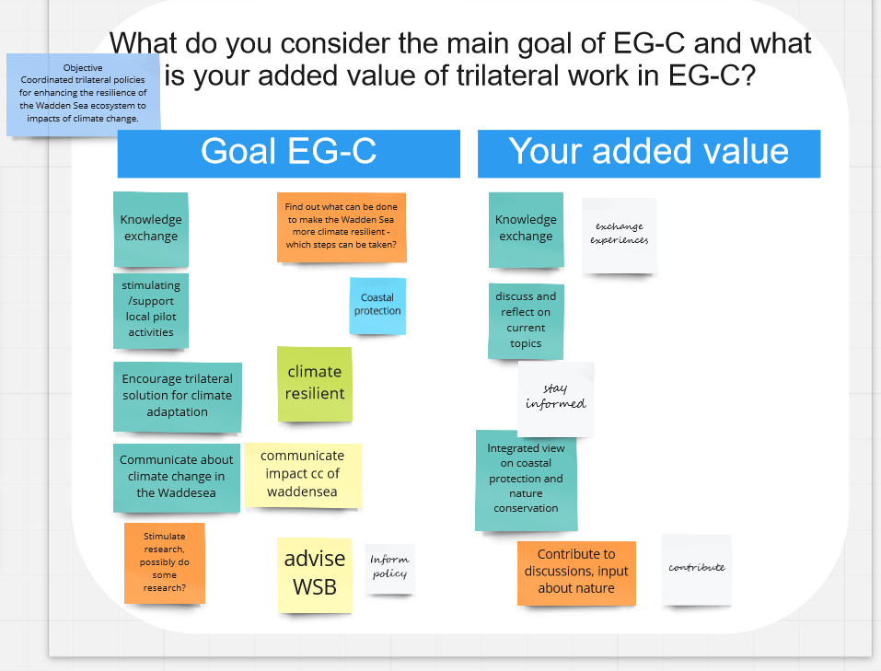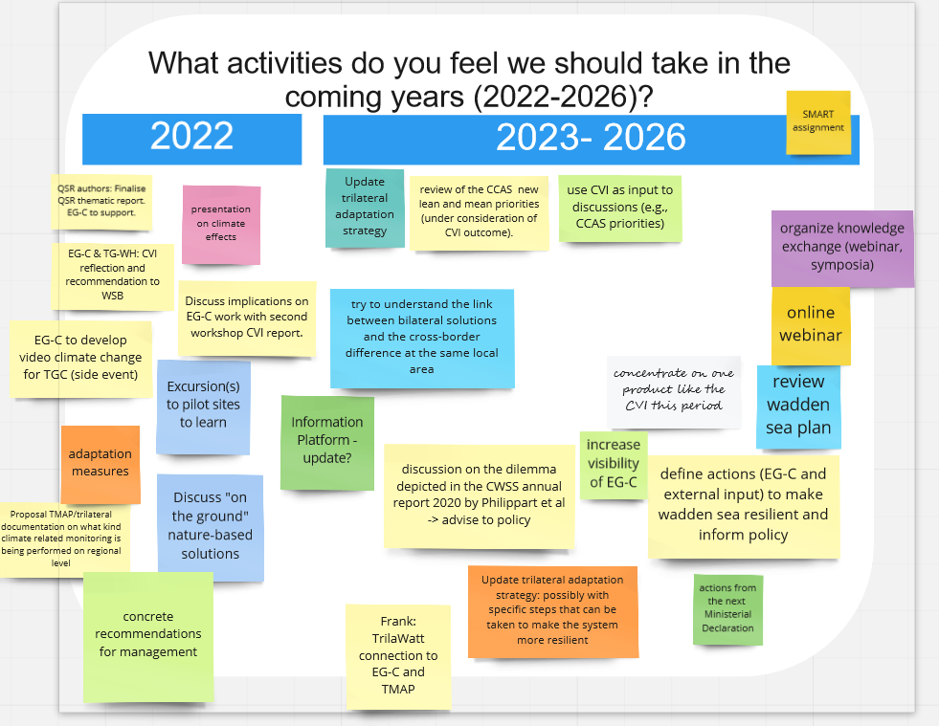
Which additional issues should we tackle?
Is there any issue of urgency?the right experts in the group
More resilient = decrease of use and add connections and brackish areas, how to accomplish this?
climate and alien species: discover links with

