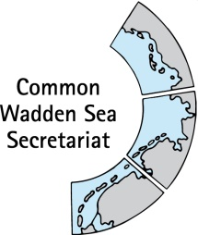
MEETING DOCUMENT
Task Group Management (TG-M 20-3)
20 October 2020
Online meeting

Agenda Item: 4. Implementation of the Leeuwarden Declaration
Subject: Overview on TG-M relevant tasks of the Leeuwarden Declarations
Document No.: TG-M 20-3/4.1
Date: 19 October 2020
Submitted by: CWSS

This document contains an update on progress on paragraphs of the Ministerial Council Declaration of the13th Trilateral Governmental Conference on the Protection of the Wadden Sea (Leeuwarden Declaration), which are relevant for the Task Group Management (TG-M).
Items in brackets are temporary dealt with in TG-M but will need further allocation within the Trilateral Wadden Sea Cooperation (TWSC).

Proposal: The group is invited to note the information and proceed as planned.

Overview on progress on relevant articles of the Leeuwarden Declaration
Work plan 2020 of the Task Group Management (TG-M) see Annex 1.
5.1 Paragraph 5 & 12: Flyway & Breeding Birds
§5 Wadden Sea Flyway Initiative (WSFI): The 1st stage IKI project application ‘Climate Resilience for Critical Sites for Migratory Birds and People along the East Atlantic Flyway’ (Short Title: Climate Resilient East Atlantic Flyway) is on-going.
The technical outline (functionality, navigation, view) for the WSFI microsite (template) is being implemented and CWSS stays in contact with Creative Concern as microsite. This microsite will serve as template for subsequent sites, e.g., for Swimway and Alien Species (see 5.2 and 5.6).

Proposal: Note the information

5.2 Paragraph 13: Swimway
In their WG-Swimway 20-1 to 20-3 meetings, and in an additional topical meeting on Terms of Reference (ToR) and member composition for their possible transformation to an Expert Group Swimway, the ad hoc Working Group Swimway (WG-Swimway) came up with:
- ToR for a possible Expert Group Swimway (see TG-M20-3-4-2-WG-Swimway-ToR);
- Draft policy review and executive summary with policy recommendations to TG-M (Executive summary see TG-M20-3-4-3-WG-Swimway-Policy-summary);
- Agreement to establish a sub-unit to deliver fish monitoring recommendations to the Task Group Monitoring and Assessment (TG-MA).
In addition, the group proceeded with proposal preparation for national projects (a German bottleneck project and a Danish project to complement the Dutch Swimway project). Further, a trilateral research project workshop was held on 8 October 2020, in which invited scientists agreed to prepare a joint proposal for a meta-analysis of existing datasets. Therewith, WG-Swimway has fulfilled its envisaged tasks for 2020.
Further, a Swimway website will be established as microsite, in the sequence: Flyway, Swimway, Alien Species (see 5.1 and 5.6).
Proposal: Note the information

5.3 Paragraph 14: Wardening & management
At TG-M 19-2 it was decided that the Dutch obligation for organisation of a Wardening workshop early 2020 should be inquired.
Proposal: Proceed as planned.
5.4 Paragraph 15: Seal Management Plan
- The EG is working on a paper summarizing some recent setbacks in the seal monitoring and to address these issues (probably in TG-M).
- There is a good number of abstracts on Marine Mammals for ISWSS from EG members, but also one from ASCOBANS who would like to further cooperate with CWSS.
- A harbour porpoise workshop event is planned the day before ISWSS as a side event and as follow-up of the 2019 symposium and workshop.
Proposal: Note the information.
5.5 Paragraph 16: Harbour porpoises
- Ongoing discussion on the adjusted ToR regarding the consideration of harbour porpoises in th EG-Seals (towards EG-Marina Mammals).
- The envisaged harbour seal workshop in the scope of the 30th anniversary of the seal agreement will be postponed to near year due to COVID-19 restrictions. Postponing is possible since the agreement actually came into force in 1991 (in was only concluded in 1990).
Proposal: Note the information

5.6 Paragraph 17: Alien Species
The planned alien species network platform will be established as microsite (following the Flyway and Swimway sites). The technical outline (functionality, navigation, view) for the site has been developed and CWSS maintains contact with Creative Concern to implement the platform as microsite. The upload of content will follow in cooperation with EG-AS.
Proposal: Note the information

5.4 Paragraph 21: Sustainable fisheries
See separate documents under agenda item 6 single integrated management plan (SIMP)

5.7 Paragraph 22 - 23: Marine litter
At TG-M 19-2 the group had agreed to produce the inventory in the form as submitted as a quick and thorough overview to the next TG-M meeting, [..] and then discuss on how to proceed for a possible Marine Litter document at WSB 31. It was agreed upon to discuss next steps again at the TG-M 20-3 meeting.

Proposal: Note the information and agree on next steps.

5.10 Paragraph 29: Energy
See agenda item 6 single integrated management plan (SIMP)

5.11 Paragraph 30-34: Ports and shipping
See separate agenda item 5 and documents therein.

Proposal: Note the information

Items with finalization pending from Tønder Declaration:
5.12 Paragraph 23: N2000 roof report
An update for the N2000 FR could be: The FR is in process at AUC-DCE based on the proposal seen by TG-M and the comments given by the members. A short description of the implementation of N2000 in a Wadden Sea context in the 3 countries, matching one done for DK, is requested.(Danish contribution attached, see Annex 2).
Proposal: Note the information and proceed as planned.

ANNEX 1: Work Plan 2020 Task Group Management (TG-M)
Table: Work plan 2020 of the Task Group Management (TG-M) with deliverables/products of the group´s responsibility in black, and supervision and coordination activities in grey. Items in brackets are temporary dealt with in TG-M but will need further allocation within the TWSC (e.g., Partnership Hub) (Work Plan as amended at TG-M20-2 2020-05-14) and submitted to the Wadden Sea Board (WSB) at their 31 meeting on 18 June 2020-.
Leeuwarden Declaration | TG-M role | Products 2020 (what) | Responsible group/body/person (who) | Time schedule incl. milestones (when)
3. Single integrated management plan (SIMP) | Support and contribute | First final draft of the complete SIMP | TG-WH, CWSS (SIMP officer) | 2020-11
3a Tourism | None | Content on chosen SIMP key topic headings | NG-ST leads, Support managers and TG-MA | TBD by NG-ST
3b. Fisheries | Responsible | Proposal working approach | TG-M | 2020-03 (TG-M 20-1)
 |  | Content on SIMP key topic headings “Inventory” and “Common ground" | TG-M and fisheries specialists (potential Task Group or Round Table) | 2020-03 Basic info  2020-06  2020-09 Revision
 |  | Content on SIMP key topic headings "Strategies and actions for management" based on "Threats and opportunities" and considering "Climate change" | TG-M and fisheries specialists (potential Task Group or Round Table). | 2020-06 to 2020-09  Workshop or meeting of fisheries specialists (potential Task Group or Round Table)  First Draft and Revision  2020-09-20 Revision
 |  | Overview on fish monitoring and data | Ad hoc WG SWIMWAY | DONE 2019
3c. Shipping and ports | Responsible/Support | Content on SIMP key topic headings “Inventory”, "Strategies and actions for management" based on "Threats and opportunities" and considering "Climate change" | WSF, with support from TG-M and CWSS. | TBD WSF
3d. Renewable energy, Energy from Oil and Gas, (Coastal flood defence and protection) | Responsible  (Support) | Proposal working approach | TG-M/SH | 2020-03 (TG-M 20-1)
 |  | Content on SIMP headings “Inventory” and “Common ground | TG-M/SH, CWSS (SIMP officer) (EG-C responsible for coastal flood defence and protection) | 2020-03 Basic info  2020-06  2020-09 Revision
 |  | Content on SIMP key topic headings "Strategies and actions for management" based on "Threats and opportunities" and considering "Climate change" | TG-M, CWSS (SIMP officer), and depending on working approach proposal. Collaboration with EG-C for climate change as appropriate.  (EG-C responsible for coastal flood defence and protection) | 2020-06 to 2020-09  Workshop or meeting depending on working approach proposal  First Draft and Revision  2020-09-20 Revision
 |  | Monitoring, data collection and data management | TG-MA | TBD TG-MA
5. Wadden Sea Flyway Initiative (WSFI) | Observe | Arctic Cooperation | WSFI SG | 2020-11
 | Observe | Monitoring of key sites along Flyway |  | 2020-02, on-going
 | Observe | Capacity Building |  | On-going
12. Breeding Bird Action Plan | Oversee | Breeding bird trend report | EG-MB/BB | 2020-08
13. SWIMWAY | Observe/  support | Implementation SWIMWAY Vison | TG-M/ad hoc WG SWIMWAY
 | Observe/  support | ToR and work programme for EG Fish |  | 2020-11
14. Management & Wardening | Responsible | (Site) Managers Workshop | TG-M
 | Responsible | Wardening Workshop |  | TBD (to account for COVID 19)
15. Seal Management Plan 2018-2022 | Evaluate and support | SMP and Annual Reporting | EG-Seals
 | Oversee | Annual Reporting on harbour seal and grey seal population |  | 2020-07 and -11
16. Harbour porpoises | Observe and evaluate | Inclusion to ToR of EG-Seals | EG-Seals | 2020-11
17. Alien Species (MAPAS) | Oversee | Implementation MAPAS / Alien Species Platform | EG-AS | 2020-11 (on-going)
20. Quality Status Report | Support | Draft Proposal for next QSR (joint note TG-MA TG-M) | TG-MA | TBD TG-MA
21. Sustainable fisheries | Responsible | Inventory on fishery activities in the Wadden Sea Conservation Area. | TG-M/CWSS | 2020-06  (compare SIMP 3b)
 |  | Document with status and recommendations for principles of the Framework Sustainable Fishery | TG-M/CWSS | TBD
22.-23 Marine litter | Responsible/Support if needed/Ignition phase | Inventory on activities | [TG-M] NL/D/ QSR thematic report authors/ TG-WH | 2020-xx for WSB 32
[24. Light emissions] | Support | Inventory on activities | WSF/Partnership Hub
29. Renewable energy and its transportation | Responsible | Overview on concepts for renewable energy transport/sea floor /(Inventory study 2020) | TG-M (DK, D, NL, coordination by ?) | TBD (compare SIMP 3d)
[30.-34. Sustainable –Shipping and Ports] | Responsible | Concept on Awareness and Education | TG-M | TBD (compare SIMP 3c)
 | Support | WSF Round table approach | [WSF in collaboration with TG-M] | TBD (compare SIMP 3c)
36. Joint Program on Research | Support | Installation of T Programming Committee on Wadden Sea Research | TRA-RMC | TBD by TRA-RMC/WSB
44. 15th International Scientific Wadden Sea Symposium | Support | Establishment of planning committee and organisation | Schleswig-Holstein | 2021-03-23 to 2021-03-26
Wadden Sea Plan (WSP) | Supervise | Implementation of WSP/Towards technical update of WSP | [TG-M] | On-going

ANNEX 2: Implementation of EU N2000 directives in Denmark
with special focus on the Wadden Sea
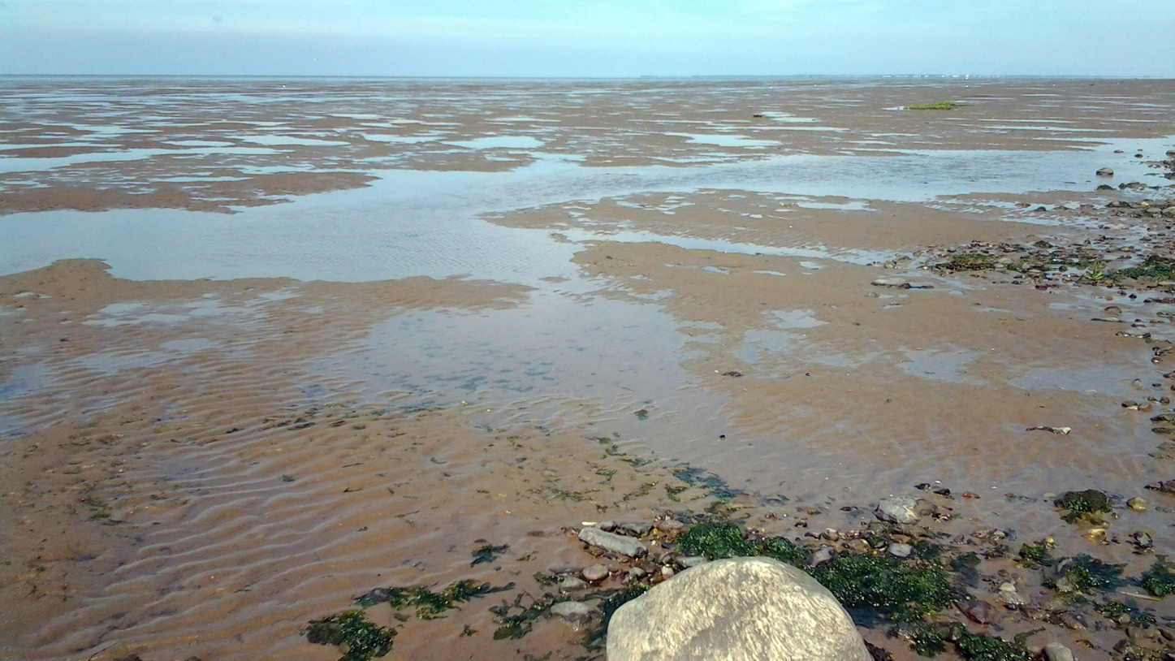
The EU's Natura 2000 directives (Bird Protection Directive and Habitats Directive) oblige European member nations to make the necessary efforts to secure or restore a range of rare, endangered or distinctive habitats and species of European importance, and Denmark has chosen to implement the obligations through a systematic and recurring Natura 2000 planning, which prioritizes the required effort on the basis of the directive commitment and national nature monitoring for 6-year planning periods.
Against this background, Denmark is currently preparing plans for the third generation for the years 2022-2027, re. Annex1. However the specific example below “N89 Wadden Sea, partial plan for F65 Rømø” is 1 of 10 plans of the present 2nd generation plan covering the Danish part of the WS.
Of the Danish land area, 8% and of the marine areas 18% are designated as N2000 areas, a total of 252 single areas, of which 10, as mentioned, covers the Wadden Sea area. However, more than 252 habitat and birds areas exist (269 and 124, respectively), but as these may be coincident or be in close proximity to each other, the total number of coherent N2000 areas is 252.
The Natura 2000 plans are prepared after prior discussion with the relevant government, regional and municipal authorities and with the involvement of national park boards, associations, organizations and landowners who have a significant interest in the plans. The cross-cutting, overall discussions take place at national level. At the regional level, the Danish Environmental Protection Agency presents baseline analyzes and a possible plan content is discussed. The baseline analyzes are published at the same time as discussions with the stakeholders are initiated.
In the aquatic area, efforts are to a large extent based on that laid down in the river basin plans, which aim to improve the aquatic environment towards good ecological status. This will at the same time provide improvements in water quality and physical conditions in watercourses (eg removal of barriers), which are necessary to achieve good natural conditions for the water areas also designated as Natura 2000 areas, including i.a. the rare houting in the Wadden Sea area.
Natura 2000 planning is carried out, among other things, in accordance with the rules of the Environmental Objectives Act and related regulations, and the N2000 planning process results in the following 5 sub-elements for each of the 252 individual N2000 areas (links refer to one of the 10 sub-plans for the Wadden Sea sub-plans: 89 Wadden Sea, part plan for F65 Rømø):
1) Natura 2000 plan
2) Consultation report
3) Summary statement
4) Strategic environmental assessment of the plan proposal
5) Baseline Analysis - Revised Edition
Re. 1) The Natura 2000 plan consists of objectives for the natural state in the Natura 2000 area and an intervention program. The action program for each Natura 2000 site is prepared on the basis of a baseline analysis and available monitoring data.
Re. 2) The consultation report summarizes comments and objections from the public consultation period.
Re. 3) The summary report has been prepared on the basis of the environmental report for proposals for the Natura 2000 plan, and has been used as a basis for (political) decision in connection with the adoption of the Natura 2000 plan, and specifically addresses:
• The purpose of the Natura 2000 plans and their environmental impact
• How is the environmental report taken into account?
• How are opinions received during the consultation phase taken into account?
• Alternatives that have been included in the environmental assessment
• Monitoring the effect of the Natura 2000 plan
Re. 4) The strategic environmental assessment is carried out in accordance with Statutory Order No. 939 of 3 July 2013 on environmental assessments of plans and programs
Re. 5) The baseline analysis presents the data and contains the following elements:
• Mapping habitat types and habitats for species for which the areas are designated.
• Assessment of condition and preliminary assessment of threats.
• A summary indicating on the map annex the location of the mapped areas and the condition.
Once the N2000 plans have been adopted, municipal councils and other authorities, in exercising their powers under the legislation, are bound by the plans, and specific municipal action plans are drawn up.

Oversee: Processes and products are followed and aligned to trilateral policy and coordinated where necessary

