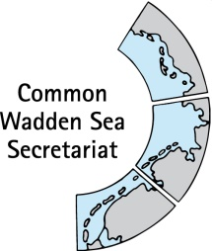
MEETING DOCUMENT
Task Group Management (TG-M 20-3)
20 October 2020
Online meeting

Agenda Item: 5. Shipping
Subject: MSC Zoe next steps
Document No.: TG-M 20-3/5/1
Date: 16 October 2020
Submitted by: Karst Jaarsma/Floris van Bentum

In the night of 1 to 2 January 2019, the MSC Zoe with more than 8000 containers on board was travelling from Sines in Portugal to Bremerhaven in Germany. North of the Dutch Wadden Islands, the MSC Zoe found itself in severe weather. The ship lost 342 containers. The cargo comprised a wide range of items and packaging materials that on the subsequent days washed ashore on the coastline of the Wadden Islands.
This occurrence caused the Dutch Safety Board to initiate two investigations: a combined international investigation with Panama and Germany into the course of events of the accident and an investigation by the Dutch Safety Board itself into the risks on the shipping routes north of the Wadden area.
The investigation by Panama Maritime Authority, Dutch Safety Board and BSU has been published on 25 June 2020 . The report itself has been attached. Earlier on it was decided that the Wadden Sea Board will come with an official response on the outcomes of the investigation. Questions to discuss at TG-M are:
- What are the next steps in regards to the recommendations made in the various countries?
  - PM – Suggestion to add this in an attachment towards the Wadden Sea Board
- Do we foresee a role for the Wadden Sea Board to contribute positively to the process and/or speed up decision making?
- What can the Wadden Sea Board do besides the official recommendations?
- What should the official response by the Wadden Sea Board contain?.

Proposal: Discuss next steps in the TG-M

