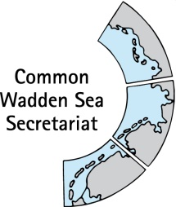
MEETING DOCUMENT
Task Group Monitoring and Assessment
TG-MA 21-3
19 April 2021
Online meeting

Agenda Item: 4. TMAP and data handling
Subject: TMAP parameter workshops guidance
Document No.: TG-MA 21-3-4-1
Date: 13 April 2021
Submitted by: Chairperson / CWSS

TMAP parameter workshop guidance:

Objectives of the Expert Workshops 2021 decided by TG-MA with a view on a) improving the TMAP
b) develop common monitoring programmes (including methods and data handling) and c) delivering comparable information for all Wadden Sea regions for the topics:

- Salt marshes / Beaches and dunes (lead: Mr Vossebelt, Mr Scheiffarth)
- Geomorphology (tidal flats)/Hydrology (lead: Mr Kellermann, Mr Eskildsen, Mr Frederiksen)
- Subtidal habitats (lead: Mr Eskildsen, Mr Vossebelt)
Please consider the following questions during the development of the workshop concepts:

1. What programmes are currently operating under the TMAP umbrella?
2. Are the current methodologies, i.e. spatial/temporal resolution, equipment, data processing, comparable across regions? (this analysis should consider the objectives of regional programmes and their suitability for the TMAP and the ecosystem approach)
3. Is there an advanced and innovative, cost effective approach available that can be applied in all regions? Are there alternative options to obtain comparable data sets?
4. Are there possible synergies for the specific thematic fields, as the transition from tidal flats across beaches, salt marshes and dunes could be considered as a continuum?

Proposal: The meeting is invited to note and discuss the document.

