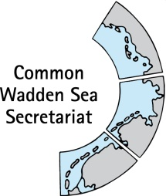

TASK GROUP
World Heritage
TG-WH 26

31 January – 1 February 2019
Bremen

_________________________________________________________________________

Agenda Item: 7

Subject: 10th Anniversary Wadden Sea World Heritage

Document No. TG-WH 26/7/3

Date: 15 January 2019

Submitted by: CWSS

_________________________________________________________________________

Attached is the final partner guide for the WH Bike Tour 2019 on the occasion of the 10th Anniversary Wadden Sea World Heritage.

The guide has been prepared by the CWSS in cooperation with the regional coordinators (see section 5).

Proposal

The meeting is proposed to note the document.

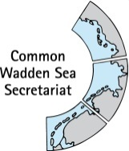
One Wadden Sea. Two wheels. Three countries.
Wadden Sea World Heritage Bike Tour 2019
Organisers’ guide
(last updated 7.1.2019)
- Introduction
- Purpose
- Themes
- Context
- Target audience
- Event organisers and contact
- Participation as event partner and general condition
- Organisational aspects Bike Tour
- Day-by-day
- Deadline for submission of applications
- Selection process and development of the programme
- Media programme
- Communication, promotion and branding

- Introduction
In 2019, under the motto “One Wadden Sea: Our Heritage. Our Future.” the Wadden Sea World Heritage (WSWH) will celebrate the 10-year anniversary of its inscription on the World Heritage List (26 June 2019). The year will also mark the 5th anniversary of the designation of the Danish part of the Wadden Sea as World Heritage.
Highlight of the anniversary celebrations will be the Wadden Sea World Heritage Bike Tour in June 2019. Under the umbrella of the anniversary motto the tour will carry the slogan “One Wadden Sea. Two Wheels. Three Countries.” In mid-June two core cyclist groups will start in the Netherlands, and in Denmark and bike to Wilhelmshaven. En route and over the course of 10-14 days, the cyclists will stop at designated spots of participating partners, where highly-engaging activities for locals and tourists/guests are planned. The core teams can be joined on a daily basis or by interested groups and individuals, while high-level personalities (e.g. ministers) and celebrities are asked to join for daily stages for at least part of the way leading to the local events. On 30 June the two cyclist groups will meet at the Wadden Sea World Heritage Visitor Center in Wilhelmshaven, where a trilateral festival will mark the end of the tour.
The tour is the highlight of an anniversary programme with various events throughout the year 2019. All anniversary events will be communicated as part of the anniversary celebrations and will be published in the trilateral anniversary programme online in Danish, Dutch, English and German.
This guide explains how the Wadden Sea World Heritage Bike Tour will be organised and defines the roles and tasks of the organisers and various event partners in managing the tour.
- Purpose & themes
The Wadden Sea World Heritage Bike Tour is the only cycling event that unites the Wadden Sea for World Heritage and for preserving the OUV. The overall message of the event is “One Wadden Sea. Two Wheels. Three countries.”
The event aims to:
- raise awareness on the Wadden Sea’s uniqueness and fragility;
- bring together people from different Wadden Sea regions;
- unite the local anniversary celebrations across the transnational site;
- support sustainable ways of experiencing the Wadden Sea World Heritage site.
There are two themes:
  - Sustainability
By cycling the route in the most sustainable way possible and creating events with sustainability standards in mind, the tour demonstrates how the WSWH site can be enjoyed by means that also serve the preservation of the OUV.
  - Collection
The theme of collection puts an emphasis on the stations of the route. The idea is to collect birthday wishes and personal stories from each local stop (from the regions, our partners and the public) to form a collection to show the variety of the regions which are united by our World Heritage site. The collection is intended to travel through the Wadden Sea Region as an exhibition after the tour and find a permanent home in the Wadden Sea World Heritage Partnership Center in Wilhelmshaven in 2022.

- Context
Beyond contributing the bike tour in June 2019, there is also the opportunity to get engaged with the 10th anniversary celebration by integrating the 10th anniversary in local events during the entire year under the motto “One Wadden Sea: Our heritage. Our future.”
All partners in the Wadden Sea region are invited to create anniversary events and/or include the anniversary motto in their regular events throughout the year. Information about the local anniversary events should be provided to their regional contact points (see #5), who will also inform the Common Wadden Sea Secretariat (CWSS) in order to promote these events to a broader (international) audience on the official anniversary event’s webspace. This will enhance interest in and profile your event on international scale.
Events should transpire the significance of preserving the Wadden Sea World Heritage for future generations. They should also hold a high standard of sustainability.
By staying open to all, be it resident, tourist, politician, NGO, the tour invites people to become active, learn about the Wadden Sea World Heritage and ultimately become advocates for its conservation for future generations to enjoy.

- Target audience
The Wadden Sea World Heritage Bike Tour in June 2019 and its events are celebrations of the Wadden Sea World Heritage and its designation. Therefore the tour is first and foremost aimed at those, who live at the site: the residents. This group also includes local SMEs, NGOs, associations, Wadden Sea partners.
The second target group are tourists and guests interested in joining the tour for 1-3 days. The tour can be accompanied by whoever would like to. The daily routes will be made public.
As the tour aims primarily at raising awareness, the media is the third target group.
- Event organisers and coordinators
The Wadden Sea World Heritage Bike Tour is jointly organised by the CWSS, Nationalpark Vadehavet, the German National Park Authorities Wadden Sea and the joint Dutch Wadden Sea marketing organisations in the framework of the Trilateral Wadden Sea Cooperation. The organisers are responsible for the design and structure of the tour and its programme, for general coordination and communication with all partners.
On behalf of the organisers, the regional coordinators will provide organisational support for the event partners serving as their main contact point. Overall coordination across the regions including setting up an overall programme and online presentation is provided by CWSS.
Regional focal points / contact details:
Denmark | Anne Husum Marboe, Nationalpark Vadehavet – The Wadden Sea National Park,  anhma@danmarksnationalparker.dk | +45 72 54 36 51
Schleswig-Holstein | Marina Sanns, Landesbetrieb für Küstenschutz, Nationalpark und Meeresschutz Schleswig-Holstein,  marina.sanns@lkn.landsh.de | +49 4861 616-45  Silke Ahlborn, Landesbetrieb für Küstenschutz, Nationalpark und Meeresschutz Schleswig-Holstein,  silke.ahlborn@lkn.landsh.de | +49 4861 616-78
Hamburg/Neuwerk | Janne Lieven, Behörde für Umwelt und Energie der Freien und Hansestadt Hamburg, Nationalpark-Verwaltung Hamburgisches Wattenmeer, janne.lieven@bue.hamburg.de | + 49 40 428.40.2457
Niedersachsen | Anke Hofmeister, Nationalparkverwaltung Niedersächsisches Wattenmeer, anke.hofmeister@nlpv-wattenmeer.niedersachsen.de | +49 4421 911-157
Netherlands | Karina Pool, Merk Fryslan,  karina@merkfryslan.nl | +31 6 294 98 644
Trilateral coordination | Annika Bostelmann, Common Wadden Sea Secretariat  bostelmann@waddensea-secretariat.org | +49 (0)4421 9108 19

- Participation as event partner and general condition
The following can become event partners:
- Municipalities in the Wadden Sea Region;
- Wadden Sea World Heritage Visitor Centers and National Park Houses (& National Park Schools & Junior Rangers);
- National Park Partners
- NGOs and associations in the Wadden Sea Region;
- Tourism associations in the Wadden Sea Region;
- SMEs in the Wadden Sea Region, who contribute to the protection of the Wadden Sea World; Heritage by offering sustainable products and services.
Conditions of participation
In order to become an event partner at the Wadden Sea World Heritage Bike Tour, interested parties must also meet the following conditions.
Obligatory (must):
- Deliver the message of the Wadden Sea’s Outstanding Universal Value as the largest unbroken tidal flat system in the world with global significance (www.waddensea-worldheritage.org). The event guest should learn about why the Wadden Sea qualifies to be on the List of World Heritage for humankind and possibly gain more in-depth knowledge of one of the reasons (e.g. biodiversity, ecological dynamics, geological history). The event also should tell and visualize the WSWH story (what makes us World Heritage).
- Concept: The event should relate to the anniversary motto “One Wadden Sea. Our heritage. Our future.” by pointing towards the significance of the three Wadden Sea countries working together in the framework of the Trilateral Wadden Sea Cooperation for preserving the World Heritage site and its value for future generations.
- Sustainability: Event partners are required to hold a high standard of sustainability as a company goal as well as for the event.
- Authenticity: The event should draw relatable ties to the nature of the Wadden Sea or sustainable development in the region.
- Quality: The event should fulfil professional standards of planning/organisation, implementation, method/didactic and communication/presentation. The number of participants should not exceed the event’s format in order for full experience of the individual participant and in line with the aim of conserving the nature.
- Inclusion: The event’s announcement should include information about accessibility for handicapped.
Desired (Should):
- Innovation: ‘The event should be innovative in terms of selection and constellation of Wadden Sea content, the time or the location. It should be perceived as something special/ new also to the residents.
- Holistic: The event should speak to head (cognitive), heart (emotional) and hand (activating) and thereby help explore the Wadden Sea holistically.
- Attentiveness and slowing down: The event should give time and space for pausing and experience the nature intensively and with all senses (especially outdoors)
- Cooperation: In order to build and/or deepen ties to multiplicators of World Heritage communication outside the nature tourism sector, event partners are highly encouraged to find new ways of cooperation for the organisation of the event.
- Valence: The event should be admissible to all but can ask for an adequate participation fee
Event partners will have technical support and promotional activities provided by the organisers. They may use the heading “One Wadden Sea. Two wheels. Three countries.” and the visual identity of the event, in accordance with the branding guidelines, as well as any promotional material produced by the organisers. Event partners are asked to use the anniversary logo in their communication. The logo will be provided by the regional focal point:
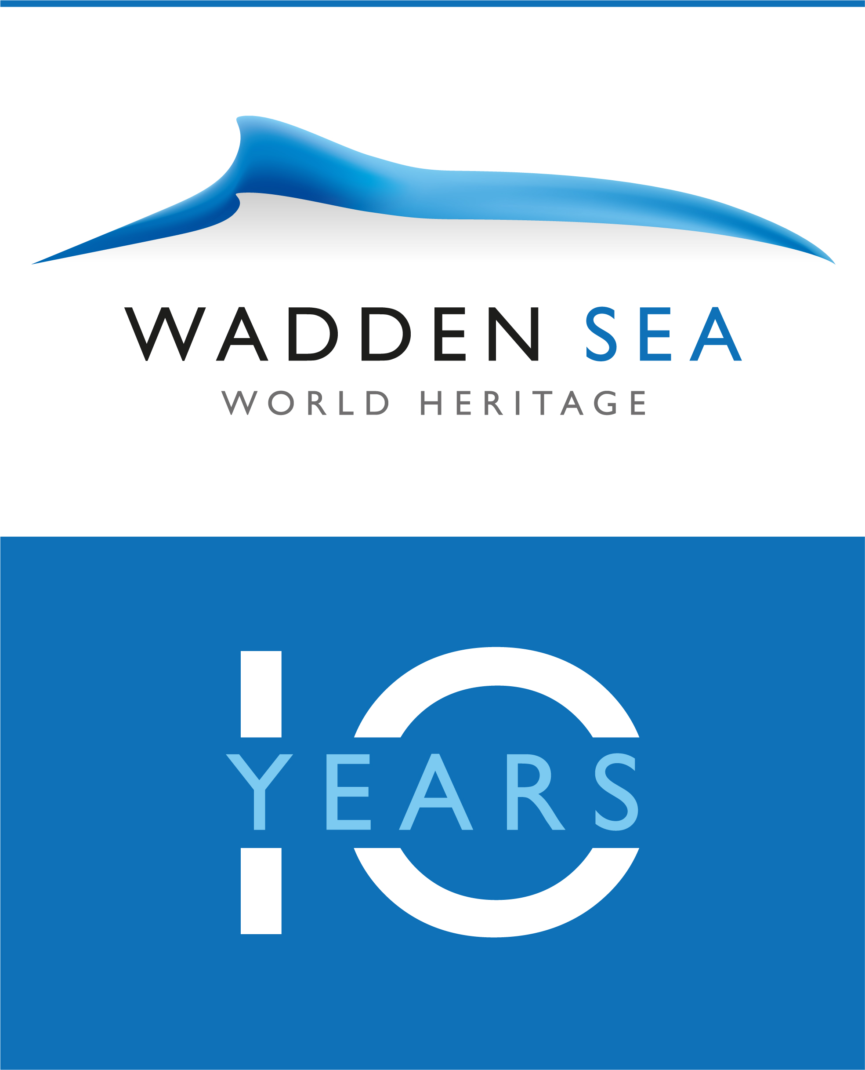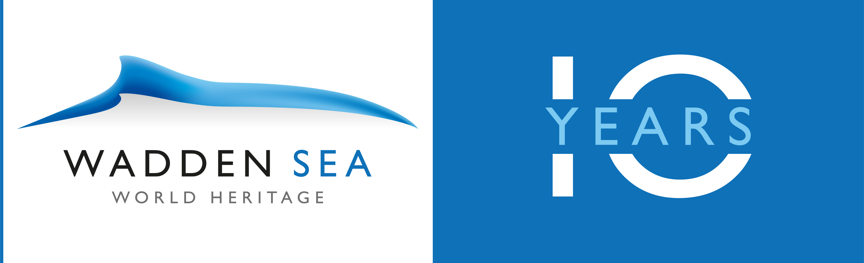

- Types of activities/ Formats of participation
Above all, the 10th anniversary of the Wadden Sea World Heritage should be a celebration to claim joint ownership of and solidarity with this unique site. Planning your event around one of the two central themes is the best way to add interest and create excitement about your celebration. It also helps tie everything together.
There are many types of activities to celebrate the 10th anniversary of the Wadden Sea World Heritage:
- Bike tour event (part of the anniversary bike tour)
- Boat excursion
- Culinary
- Cultural (music/art)
- Excursion
- Exhibition
- Mudflat walk
- Open day
- Talk/ presentation
- other
Do you have a type of activity not listed here? Approach your regional contact with your idea.
Beyond holding an anniversary or bike tour event there are many different ways of participation: from co-sponsoring events through financial support to donating goods, services, or event space. And, of course, anyone can volunteer.

- Organisational aspects Bike tour
The bike tour will take place from 14 to 30 June with two core cyclist groups starting in the Netherlands and Denmark. These groups are 5-7 people, who have Wadden Sea knowledge, engage with the media and keep social media updated on the tour and its events.
The exact event route will be released closer to the event dates via email, Facebook as well as updated on the waddensea-worldheritage.org website.
En route, the cyclists will stop at designated spots of participating partners, where activities for locals, tourists and guests are organised. The tour can be joined in on a daily basis by interested groups and individuals.
On 30 June the two cyclist groups will meet at the Wadden Sea World Heritage Visitor Center in Wilhelmshaven, where are trilateral event will mark the end of the tour. The trilateral festival is aimed at the general public and will be family-oriented with different activities by different partners exploring the Wadden Sea World Heritage and its Outstanding Universal Value.
There will be support vehicles with volunteers, first aid attendants and a bike mechanic ready to help with any problems. Cyclists will be given contact numbers for the support vehicle teams during their check-in.
Regulations of safety have to be put in place for large cycling groups (e.g. registration of event at and support by local authorities).

- Day-by-day
While the day-by-day route of the bike tour will be determined by the organisation in each region, the end date in Wilhelmshaven is set on 30 June 2019 (Sunday). On that day the two groups coming from north and west will meet in Wilhelmshaven. The finish line is the Wadden Sea World Heritage Visitor Center, where the trilateral festivities of the anniversary will be held.
The overall length of the route depends on the days each region needs for its part of the tour. At current estimation, each branch of the tour (west and north) will take about 10-14 days.
A daily plan relies on your events and will be made available soon.

- Deadline for submission of applications (for bike tour and events)
Interested partners are asked to approach their respective regional coordinator latest by February 2019.
Registration for all events is free of charge.

- Selection process and development of the programme
The regional coordinators are responsible for the tour in their regions: stops, events, route. Thus, they are also the main contact persons for event partners. The selection of event partners will be done by the regional coordinators and communicated to CWSS and the other regions.
The final event on 30 June in Wilhelmshaven will be organised by CWSS (lead coordinator), the Lower Saxon Wadden Sea National Park and the UNESCO-Wadden Sea World Heritage Visitor Center in Wilhelmshaven, with input on the programme and support of the other regions (reaching out to stakeholders, presentation of regions).

- Media programme
Encourage your community, especially local media outlets, to help spread the word about the anniversary events, the bike tour and, of course, your part in the celebrations. Social media websites, such as Twitter and Facebook, are a great way to get the word out.
Partnerships with national and regional media are planned. The regional partners will service the media in their respective region. Event partners are advised to use their own media contacts.
Social media will play a central role at the tour. The core cyclists will post and blog on various channels about their daily trips (supported by CWSS and the regional coordinator) to inform the interested public on their location, progress and the regional events visited. The posts will be published in the cyclists’ native languages as well as English. The event partners are asked to use their channels. Shared hashtags will be announced prior to the tour.
The organisers may cover travel and accommodation expenses for a limited number of journalists to join the bike tour.

- Communication, promotion and branding
The main communication platform for all information on the Wadden Sea World Heritage Anniversary Programme and Bike Tour is the website www.waddensea-worldheritage.org, shared by and linked to the organiser and event partner websites.
The event´s promotion and communication will be run both online (via website, social media, etc.) and using traditional tools. To attract media attention the organisers will provide regular newsfeed on the event with press releases, social media posts and via different websites. All partners are encouraged to coordinate their media-related activities together with the anniversary organisers to ensure consistency in the messages.
The event partners agree to adopt a common visual identity, including the use of the event logo (according to brand guidelines), available closer to the event dates via email and on the event website.

ANNEX 1
Event offer
in the framework of the Wadden Sea World Heritage anniversary 2019

Title | Precise and inviting
Event organiser | Incl. website link
Date | Wed DD.MM.YYYY
Time | HH:MM (Start)
Length | X,Y hours
Location | Address of meeting point
Public transportation | How to reach the meeting point by public transportation / closest bus or train station
Costs | e.g. adults X,- €, children under 14 years Y,- €, families Z,- € / free of charge / donations welcome
Registration | e.g. by DD.MM.YYYY at … via e-mail, phone, online
Target group | Only if event addresses or excludes a specific group:  Adults  Children  Children-friendly  Families
Accessibilty | Suited for all, not suited for…, especially suited for handicapped
Teaser text | Be precise, specific and inviting; max 190 letters incl. spaces
Event description | mind. 250 – max. 1,000 letters incl. spaces
Event summary in English | Short summary of the event description in English (250 letters)
Category | Please select a max. of 3.
 | Bike tour event (part of the anniversary bike tour)  Boat excursion  Culinary | Cultural (music/art)  Excursion  Exhibition  Mudflat walk | Open day  Talk/ presentation  other
Connection to the Wadden Sea World Heritage | Please select reasons why this event is connected to the Wadden Sea World Heritage. At least three criteria should apply.  Delivers the message of the Wadden Sea’s Outstanding Universal Value  Relates to the anniversary motto “One Wadden Sea. Our heritage. Our future.”  High standard of sustainability  Authentic ties to the nature of the Wadden Sea or sustainable development in the region  Professional standards of planning/organisation, implementation, method/didactic and communication/presentation  Announcement includes information about accessibility for handicapped  Innovative in terms of selection and constellation of content, the time or the location  Event offers to explore the Wadden Sea holistically  Event paves new ways of cooperation with new partners
Special remarks | Please remark what the participants should bring along, what aspects of sustainability are considered e.g.: bike, rubber boots, rainwear, sturdy shoes, binoculars, camera / subject to wind and weather / for the mudflat walk please bring old, close-fitting sneakers / At this dinner you can enjoy organic products from the region, organic wine as well as fairly traded coffee and tea
Photo | Please provide a representative picture for the event, min. 1920 x 1080 px
Photo copyright | © XZY  By providing the photo, the copyright owner grants the anniversary organisers permission to use it in their overall communication concerning the anniversary year.

ANNEX 2
Event partner logo
of the Wadden Sea World Heritage anniversary 2019

Event partners of the 10th Wadden Sea World Heritage anniversary “One Wadden Sea: Our Heritage. Our Future.” are asked to use the anniversary logo in their communication related to their event submitted to the anniversary programme. The logo is intended to serve as bookmark and is therefore compatible with the event partner’s design.

There are two versions of the logo: a vertical and a horizontal orientation. The event partner can use the version best suited for their design.

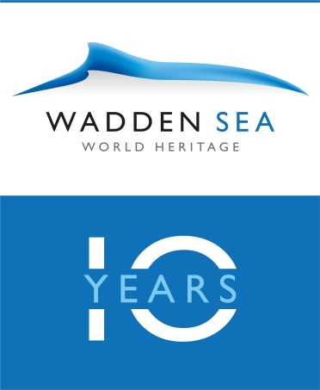

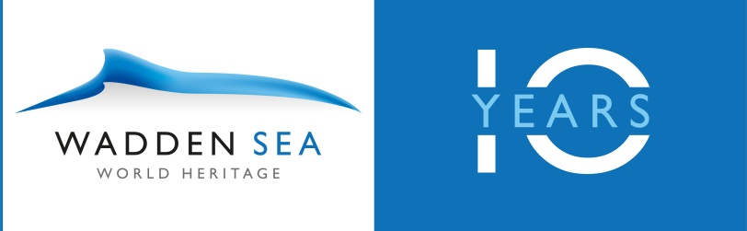

In digital publications, the event partner is asked to link the logo to
www.waddensea-worldheritage.org/anniversary

The logo may only be used communication related to the specific event(s) submitted to the Wadden Sea World Heritage anniversary.

Complimentary copies of the event announcements are highly appreciated and may be sent to:
Common Wadden Sea Secretariat
Annika Bostelmann
Virchowstrasse 1, D-26382 Wilhelmshaven

