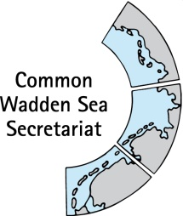

**TASK GROUP**

**World Heritage**

**TG-WH 37**

**12 and 13 July 2022**

**Online Meeting**

_________________________________________________________________________

**Agenda Item:** 6

**Subject:** New UNESCO World Heritage Logo

**Document No.** TG-WH 37/6/1

**Date:** 27 June 2022

**Submitted by:** CWSS

_________________________________________________________________________

**Background**

In 2021, UNESCO has changed its logo and the World Heritage Centre has adapted the World Heritage logo (UNESCO logo and WH emblem) accordingly. This new World Heritage logo no longer includes property-specific information (site name and date of inscription), but this can be added to the logo as properties wish.

CWSS has already contacted the three countries (UNSCO commission, competent authorities) (as reported in the TG-WH 36 document of the last meeting) and the proposal which fits to all three countries is to combine the generic UNESCO World Heritage Logo with the Wadden Sea World Heritage logo (see annex, figure 1)

At TG-WH 36, the meeting agreed to check national preferences and report to the next TG-WH meeting. The meeting is asked to come to an agreement of a common approach for the Wadden Sea in TG-WH 37 so that a decision for the new logo is ready and this can be used for any new publications such as the SIMP.

**Proposal**

The meeting is invited to decide on the use of the UNESCO WH logo for the communication of the Wadden Sea World Heritage as proposed in the annex in figure 1.

**ANNEX**





**Figure 1:** Combination of generic UNESCO WH Logo (left) and the Wadden Sea WH Logo (right) (on white and on dark background).