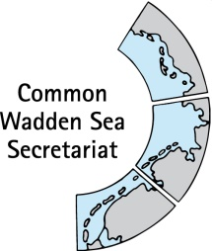

TASK GROUP
World Heritage
TG-WH 41
24 March 2023
Online Meeting

_____________________________________________________________________

Agenda Item: 5.2

Subject: OG 172 reporting

Document No. TG-WH 41/5.2

Date: 13 March 2023

Submitted by: Germany

_____________________________________________________________

As agreed at the last meeting, attached is a discussion document on OG 172-reporting to the World Heritage Center including a decision making tree for discussion at TG-WH 41.

Some discussion points are included in the document (see comments) to direct the discussion at the meeting.

Proposal

The meeting is invited to discuss a proposal to deal with reporting according to OG 172 (state party information) and to decide an the next steps.

To TG-WH
§ 172- WHC implementation guidelines- reporting to the WHC
(Draft version 16.02.23; M. Sobottka)
Why report a project or planning case to the WHC?
The three Wadden Sea states share responsibility for the protection of the Wadden Sea World Heritage Site. The World Heritage Convention obliges them to do so. Among others the WHC implementation guidelines state:
172 “The World Heritage Committee invites the States Parties to the Convention to inform the Committee, through the Secretariat, of their intention to undertake or to authorize in an area protected under the Convention major restorations or new constructions which may affect the Outstanding Universal Value of the property. Notice should be given as soon as possible (for instance, before drafting basic documents for specific projects) and before making any decisions that would be difficult to reverse, so that the Committee may assist in seeking appropriate solutions to ensure that the Outstanding Universal Value of the property is fully preserved.”
The 172 reporting by the states, together with the 174 reporting by NGOs or private individuals, is part of the WHC's broader monitoring system to oversee the preservation of the integrity and conservation of the Outstanding Universal Value of World Heritage Sites. The WHC's options for response and action are defined and encompass requests for information, voluntary advice to member states on decisions on plans or projects and an inclusion in the global list of World Heritage sites in danger, which can ultimately lead to the withdrawal of World Heritage status.
The WHC should be proactively kept at a good level of information so that in the medium to long term the basis of trust between the WHC and the TWSC and the Wadden Sea states in their willingness to take responsibility and make wise decisions is further deepened. In this way, the WHC has a good level of information in order to be able to assess reports from NGOs or private persons under Art. 174 and to weigh up whether a request for information should be made to the respective state. In recent years, we have observed an increasing number of requests for information and queries from the WHC in response to these.
In some cases, State Parties have actively informed about projects in the vicinity of the Wadden Sea World Heritage. However, the scale of the projects and their estimated potential impact on the World Heritage Site varies considerably. Both approaches, the active reporting as well as the response to the questions by the WHC, should at least be based on the fact that they involve impairments of a magnitude that actually require the involvement of WHC to deal with the respective case.
Which cases to report?
Those plans or proposed projects should be proactively reported, that are likely to have a significant negative impact on the OUV and its key values, based on available information about these plans and projects.
These plans or projects can spatially overlap with the World Heritage Site, but also may have an impact on it from outside. In addition, the interaction with other plans and projects must also be considered.
Source: UNESCO/ICCROM/ICOMOS/IUCN 2022: Toolkit for Impact Assessments in a World Heritage Context. Paris, UNESCO. https://whc.unesco.org/en/guidance-toolkit-impact-assessments/
In order to answer the question whether to report according to 172 in a coordinated manner, reference can be made here to the legal area of the EU to the environmental assessments regulations that apply equally to all and whose protected goods also cover the key values of the OUV well.
This means that all plans and projects that are subject to a formal full Strategic Environmental Assessment, an Environmental Impact Assessment and/or an formal full Appropriate Assessment (AA) according to the Habitats Directive should be reported to the WHC according to 172. In general, a potential significance for the OUV can be assumed. This procedure could create application security and conformity at the trilateral level and minimises the additional effort in implementation. Therefore, integration into these formal environmental assessment procedures is proposed.
As a supplement to this, however, a catch-all option for self-standing, specific Wadden Sea World Heritage screening should also remain possible in very rare exceptional cases, using the annexed checklist for project types and planning types (Annex 1). This check would include an individual screening about the potential impact of the project regarding the temporal and spatial scale during construction and operating phase as well as indirect and cumulative effects.
Some of the projects, such as the laying of high-voltage cables or sediment relocation, do not require an full formal environmental impact assessment, but they are of great relevance in terms of environmental impact, especially under the aspect of cumulative impacts affecting the entire World Heritage Site. In this respect, it would be advisable to actively report on these issues to the WHC in a joint dossier, as these issues in particular are increasingly brought to the attention of the WHC through notification from third parties. This would also underline that the three states are aware of their joint responsibility and keep each other informed about large-scale projects.

The decision whether to consider reporting a case might follow this decision making tree:
When best to report?
In order to determine the right time, it is important to consider the purpose of the WHC's regulations and the possible advantages and disadvantages in terms of policy. The WHC aims to support states in making good planning and permitting decisions in favour of the integrity of the WNE. However, pointing out alternatives and mitigation options or persuading them to give up on a plan can only succeed at a very early planning stage. The second important temporal aspect that speaks in favour of informing the WHC as early as possible is that of proactively anticipating a notification by third parties under Article 174, if possible, and thus avoiding requests for information from the WHC.
This time has come with the invitation to the formal scoping event to the impact assessments.
Who should report and how?
The reporting obligation formally lies with the state responsible for site management and approval of the plan or project. In individual cases, there will also always have to be some political room for manoeuvre, i.e. the final decision as to whether a project/plan is to be notified lies with the responsible ministry. As the Wadden Sea World Heritage Site is a transboundary World Heritage Site, the content of these reports shall coordinated and harmonised in a technical working group of the TWSC (TG-WH at present) in order to maintain the most consistent communication possible with the WHC on WH monitoring issues.

Annex 1: List of major project or planning types to be considered for reporting
 | Factors Affecting the Property (Per.Rep.) | Plan or project types likely to have relevant negative effects | Inside | Wider setting | Remark on effect
1 | Buldings and Development
1.1 | Housing
1.2 | Commercial development
1.3 | Industrial areas | Spatial plan, development plan, individual factory project |  | x | Depends on produce /emissions
1.4 | Major visitor accommodation + infrastructure | Spatial plan, development plan, individual project (large hotel, camping area, holiday home area) |  | x | Visitor pressure
1.5 | Interpretative and visitation facilities | Spatial plan, development plan, individual project | x | x | Visitor pressure
2 | Transportation infrastructure
2.1 | Ground transport infr. | Spatial plan, development plan, individual project (Major road, large car park, bridge etc.) | x | x
2.2 | Underground t. infr.
2.3 | Air transport infr. | Spatial plan, development plan, individual project (Airport) | x | x
2.4 | Marine transp. Infr. | Dto (harbour and port facilities, fairways) | x | x
2.5 | Traffic effects |  |  |  | Refer to 2.1-2.3
3 | Services infrastructure
3.1 | Water infr. | Development plan, individual project (Coastal defense infrastructure, dikes/ dunes, sluice, pumping station, reservoirs, sewage facility) | x | x
3.2 | Renewable energy facilities | Spatial plan, development plan, individual project (Windfarm, single turbine, wave-, solar power plant, Carbon Capture Storage) | x | x
3.3 | Non-renewable energy facilities | Development plan, individual project (Oil/ Gas Drilling) |  | x
3.4 | Localised utilities
3.5 | Major linear utilities | Spatial plan, individual project (High voltage power line, oil/ gas pipeline) | x | x
4 | Pollution |  |  |  | Only in combination with No 1-3 projects
4.2 | Groundwater poll.
4.3 | Surface Water poll.
4.4 | Air pollution
4.5 | Solid waste
4.6 | Input of excess energy | f. e. power plant using seawater for cooling
5 | Biological resource use |  |  |  | Mostly no plan or project
5.1 | Fishing/ collecting | Management plan for fisheries (Shrimp, Mussle, Oyster) | x | x
5.2 | Aquaculture | Development plan, individual project (Mussle, Oyster) | x | x
5.3 | Land conversion | Agricultural/ forestry plan | x | x
5.4 | Grazing
5.5 | Crop production
5.6 | Commercial wild plant collection
5.7 | Subsistence w.p.coll.
5.8 | Commercial hunting
5.9 | Subsistence hunting
5.10 | Forestry /wood prod.
6 | Physical resource extraction
6.1 | Mining
6.2 | Quarrying | Spatial plan, individual project (sand, silt, shill extraction) | x | x
6.3 | Oil and gas | Exploitation projects (Drilling infrastructure) | x | x | Extraction from underneath, infrastr. See 3.3
6.4 | Water extraction | Spatial plan, individual project (drinking water well) | x | x | Extraction from underneath
7 | Local conditions affecting physical fabric |  |  |  | Not relevant in general
8 | Social/ Cultural uses
8.6 | Tourism |  |  |  | Infrastructure under 1
9 | Other human activities
9.3 | Military training | Individual project (shooting range, low altitude flight area) | x | x
10 | Climate Change/ severe weather events |  |  |  | No plan or project
11 | Sudden ecol. Or geol. events |  |  |  | No plan or project
12 | Invasive Species |  |  |  | No plan or project
13 | Management and institutional factors |  |  |  | No plan or project
13.1 | Man. System/plan
13.2 | Legal framework
13.3 | Governance
13.4 | Man. activities
13.5 | Financial resources
13.6 | Human resources
13.7 | Low impact research/ monitoring
13.8 | High impact dto
14 | Other factors

Annex 2: Collection of graphic materials (to inform the discussion)
Source: Presentation of the European Commission at the 11th meeting of the Energy Community Environmental Task Force, June 2016.

Source: https://www.uvp-portal.de/de/node/308
Source: https://ec.europa.eu/environment/legal/law/10/pdf/1_Dobreva_Introduction.pdf

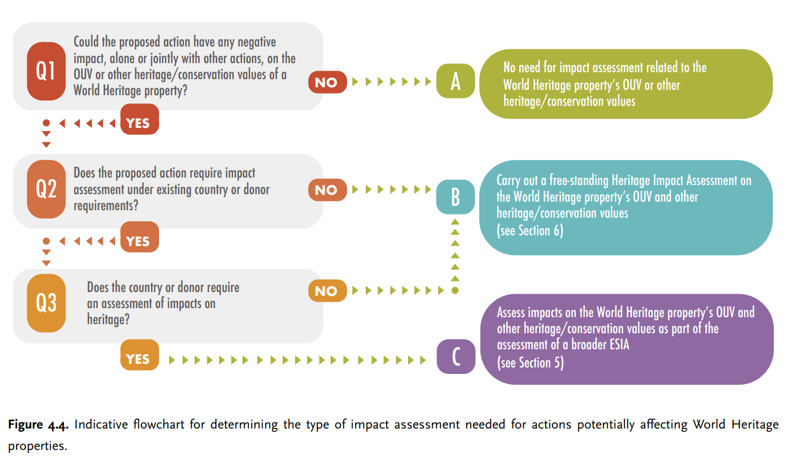
Source: UNESCO/ICCROM/ICOMOS/IUCN 2022: Toolkit for Impact Assessments in a World Heritage Context. Paris, UNESCO. https://whc.unesco.org/en/guidance-toolkit-impact-assessments/
p.34
Source: UNESCO/ICCROM/ICOMOS/IUCN 2022: Toolkit for Impact Assessments in a World Heritage Context. Paris, UNESCO. https://whc.unesco.org/en/guidance-toolkit-impact-assessments/

European Commission 2002: Assessment of plans and projects significantly affecting Natura 2000 sites- Methodological guidance on the provisions of Article 6(3) and (4) of the Habitats Directive 92/43/EEC
https://op.europa.eu/en/publication-detail/-/publication/2b6c4b16-e867-42da-b604-f67ee6fe60c3

