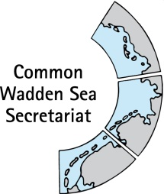
MEETING DOCUMENT
Ad hoc Working Group SWIMWAY (WG-SWIMWAY 20-1)
8 April 2020
Virtual meeting

Agenda Item: 2. Summary record
Subject: SWIMWAY webpage
Document No.: WG-SWIMWAY 20-1/5rev
Date: 1 April 20
Submitted by: CWSS, Adi Kellermann

At WG-SWIMWAY 19-3 (Agenda item 10), WG-SWIMWAY agreed that SWIMWAY Wadden Sea activities should be presented under a CWSS website, and that the group should deliver input for such an overview.
A short overview on fish in the Wadden Sea with reference to the SWIMWAY vision and action programme is already integrated to the website of the Wadden Sea World Heritage (https://www.waddensea-worldheritage.org/fish).
CWSS is currently working on a template for micro sites. SWIMWAY Wadden Sea may be presented at such a micro site.
This document contains draft specifications and first suggestions for content of such a micro site, as well as an overview for web search term “Swimway”.

Proposal: The group is invited to discuss specifications of a future trilateral SWIMWAY website, under consideration of Swimway activities worldwide.

SWIMWAY Wadden Sea website

Background
The website of the Wadden Sea World Heritage (https://www.waddensea-worldheritage.org/fish) contains information on the conservation topic fish (Our work - Conservation - Conservation projects – Fish). This sub-page includes fish targets of the Wadden Sea Plan 2010 and short information on trilateral activities, such as the SWIMWAY Vision and Action Programme. It further contains links to the Trilateral Wadden Sea Swimway Vision – Action Programme, the Thematic Report on fish of the Quality Status Report (2017), as well as to the Swimway conference 2019 (https://www.waddensea-worldheritage.org/events/swimways-understanding-connectivity-within-life-cycles-coastal-fish).
If required, SWIMWAY Wadden Sea may be presented complementarily on a micro site of the Wadden Sea World Heritage (swimway.waddensea-worldheritage.org). CWSS is currently working on a general microsite template.

Objectives and target group
- Provide overview on SWIMWAY Wadden Sea (within other SWIMWAY initiatives) Align/structure/embed SWIMWAY Wadden Sea with other SWIMWAY initiatives, e.g., World Fish Migration Day
- Inform on rationale, cooperation partners and related projects
- Increase number of SWIMWAY Wadden Sea projects and collaboration: Invite other projects or initiatives to join, link
Target group: researchers, commercial and recreational fishermen, water authorities, relevant governmental agencies and NGOs.

Technical specification
The micro site will be established as static site with few sub-pages and link to and from the Wadden Sea World Heritage website.
The SWIMWAY Wadden Sea site will be hosted as micro site of the Wadden Sea World Heritage https://www.waddensea-worldheritage.org (Figure 1). Alike the micro site of the International Wadden Sea School IWSS) http://www.iwss.org, or the Quality Status Report (https://qsr.waddensea-worldheritage.org), the overall World Heritage Cooperate Design will be kept (Figures 1, 2).
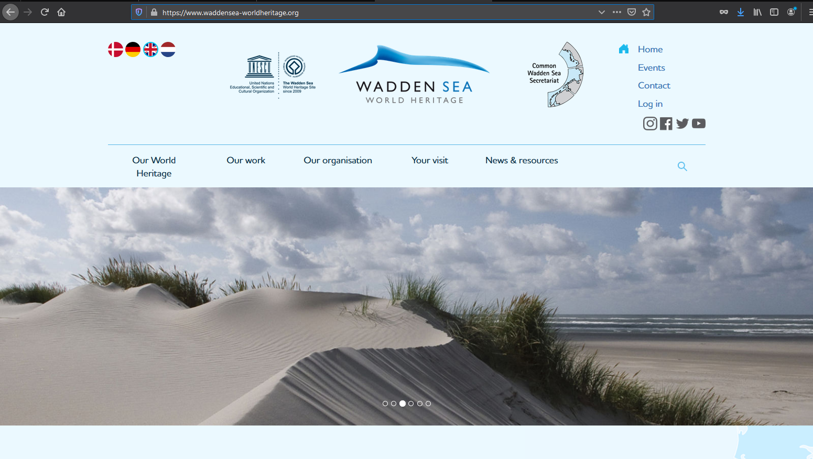 | 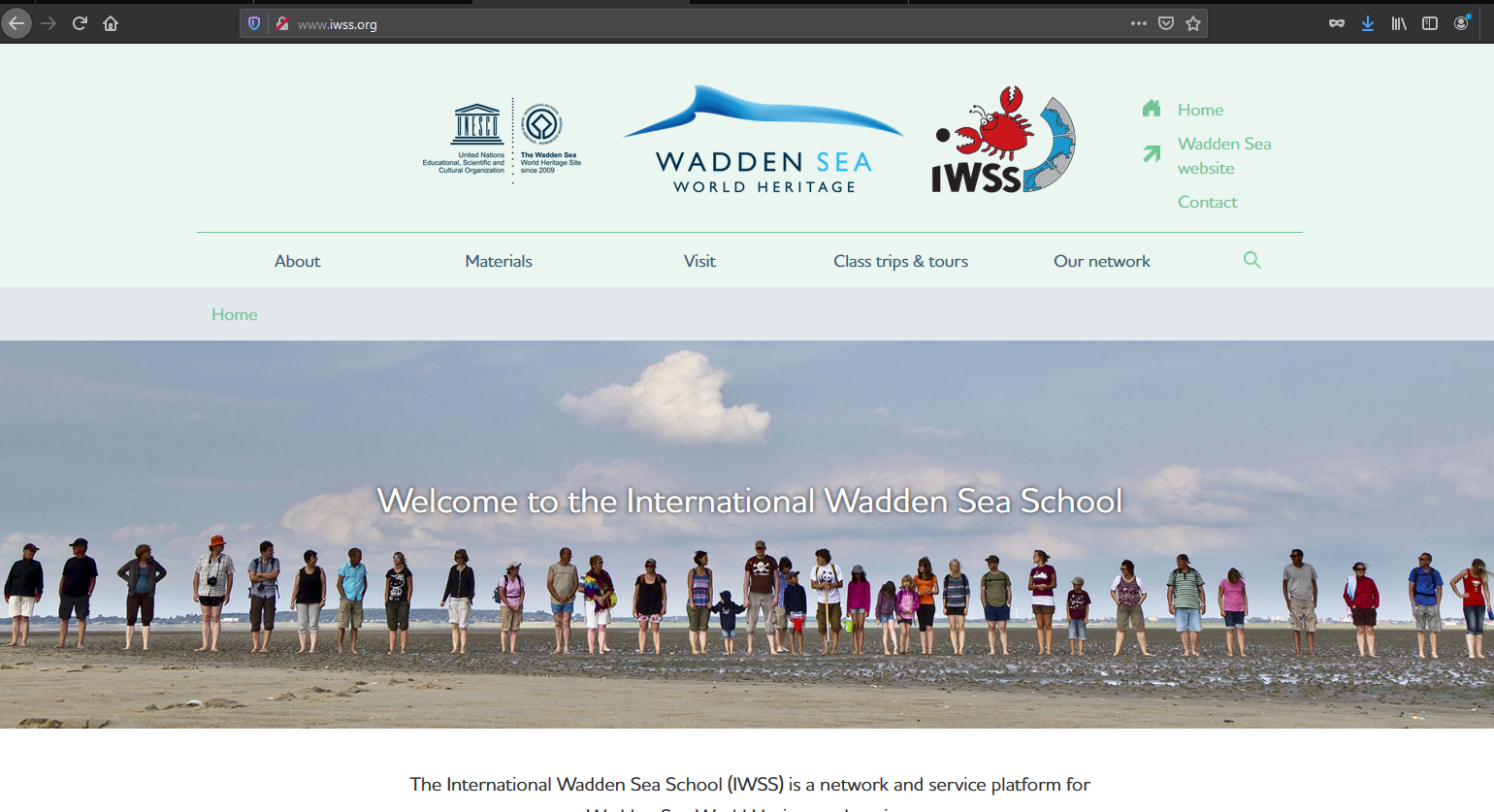
Figure 1: Screenshots of the regular Wadden Sea World Heritage site and the IWSS micro site.

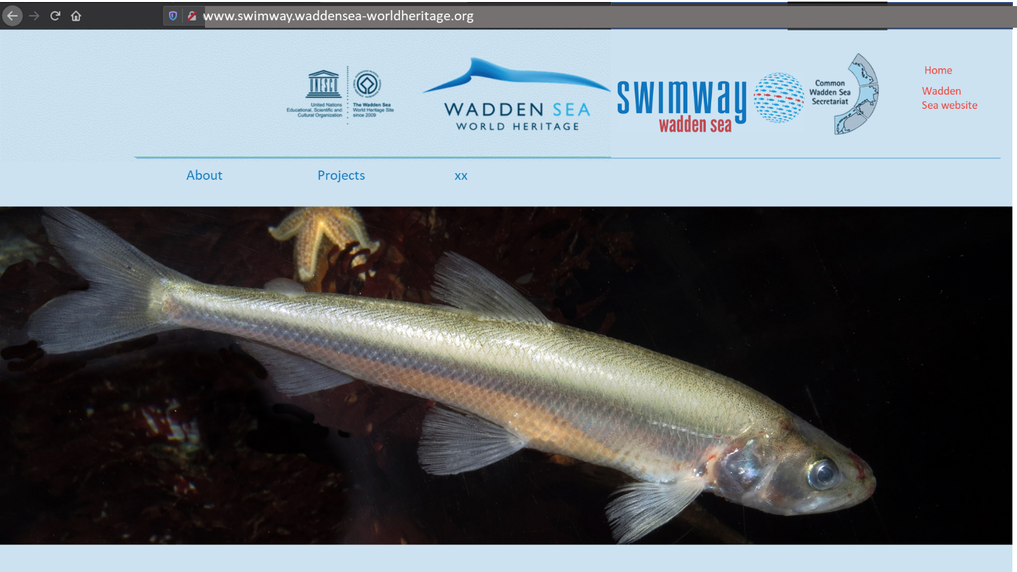
Figure 2: Mock-up of possible SWIMWAY Wadden Sea microsite.

General content and provisional site structure
Draft site map and content (estimate amount of text).
Home

About us
Needed?
Projects

Home: Welcome, brief background on SWIMWAY WS; Why is SWIMWAY needed? SWIMWAY Vision and Action Programme (four pillars) and signature of the vision; calls (e.g., looking for project partners). Estimated amount of text: TBD
About: SWIMWAY WS Programme, who are we and what do we want? Estimated amount of text: TBD
Project: List of projects. What information to include (e.g., categories) Estimated amount of text & number of projects: TBD
xx…

Time frame
First outline: May 2020.
First setup: TBD with CWSS communication officer. Preferably “home” section until May 2020.
Final draft: October 2019

Web search term SWIMWAY

Overview on SWIMWAY in the web
The term „SWIMWAY The term „SWIMWAY website“ does by no means represent a unique identifier for the Wadden Sea SWIMWAY initiative under the Trilateral Wadden Sea Cooperation (TWSC). The usual google approach yields quite a few results in addition to the pool equipment commercial sites. In only a few cases is the reader referred to the Wadden Sea initiative:
https://www.waddensea-worldheritage.org/events/swimways-understanding-connectivity-within-life-cycles-coastal-fish is leading to the trilateral conference. A short overview on fish in the Wadden Sea with reference to the SWIMWAY vision and action programme is already integrated to the website of the Wadden Sea World Heritage (https://www.waddensea-worldheritage.org/fish).
https://www.swimway.org/ refers to the global site which provides some kind of our “umbrella”.
https://www.worldfishmigrationfoundation.com/projects/4/swimway-project is another closeby activity, however the URL is a dead end (404 so not valid).
https://gprw.eu/de/projekte/swimway-vecht is a Dutch website on a transboundary (NL/D) initiative dealing with migratory fish routes and migration aids. The goal is to develop a common strategy for monitoring the fish migration up and downstream the river Vechte. The website explicitly mentions the relation with e.g., the initiative „Swimway Waddenzee“.
https://rijkewaddenzee.nl/project/visstrategie-en-ontwikkelen-swimway-benadering/ points to SWIMWAY Wadden Sea, and is hosted under programme “Rijke Waddenzee”. The website interestingly is listing for 2018-24 our goals as
- Elaborate programme proposal with coordination team and working groups
- Inspiring stakeholders to get involved
- Stimulating commitment and support from colleagues
- Highlighting showcases in the Wadden Sea
- […]
The contact is Martha Buitenkamp and Marco Blankenstijn.
Dutch Swimway project: https://www.waddenvereniging.nl/onswerk/onderwaternatuur/swimway
https://www.leonardodicaprio.org/eastern-tropical-pacific-swimway/ refers to passage ways for sharks, turtles and other marine wildlife
http://www.reachingrivers.com/swimway-africa-2/ In 2019 World Fish Migration Foundation and Reaching Rivers have formed a collaboration to take action for free-flowing rivers and fish passage in Africa, through the development of the Swimway Africa Initiative. The aim with this initiative is to create a network of 1,000 organisations working on and/or interested to get involved in projects around the theme fish passage and river connectivity in Africa.
Together with organisations, representing all 54 countries, they intend to:
- raise awareness of the social and ecological benefits of free-flowing rivers and healthy fish populations,
- improve knowledge and understanding of migratory fishes and free-flowing rivers,
- influence policy and decision makers on the topic of fish passage and river connectivity, and
- to significantly increase river connectivity and fish passage research, conservation and restoration.
The research is certainly not complete and deliberately limited to the first 9 pages of the google search results as no relevant or only indirectly relevant yields popped up further, respectively.

Screenshots of selected sites
Global: SWIMWAYs of the World
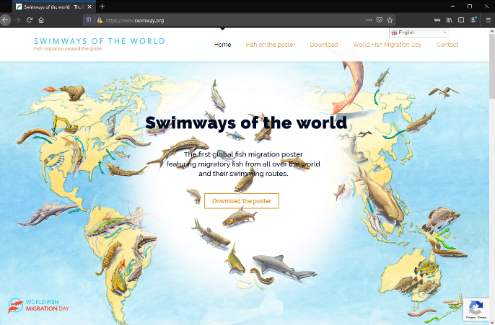

SWIMWAY Wadden Sea
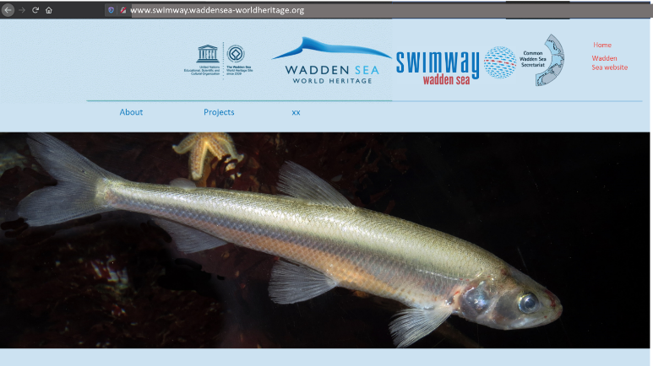
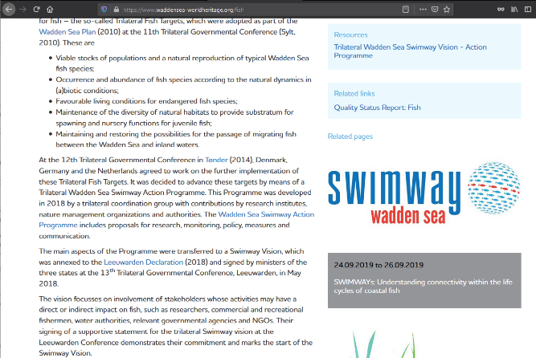
Wadden Sea World Heritage site and mock up of possible micro-site

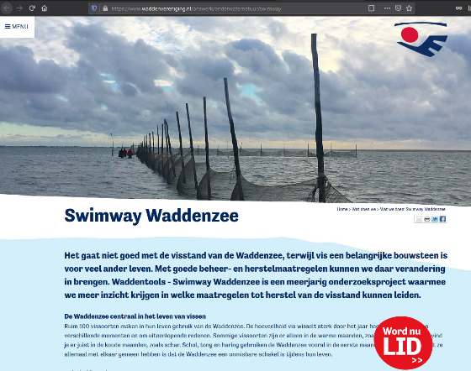
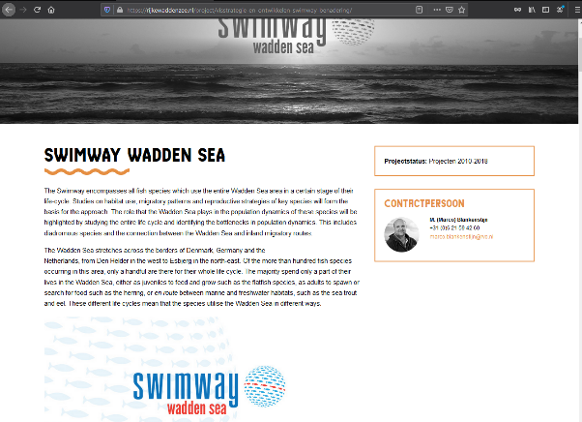
Programma Rijke Waddenzee Dutch Swimway project

